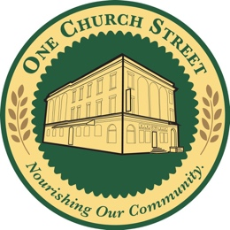

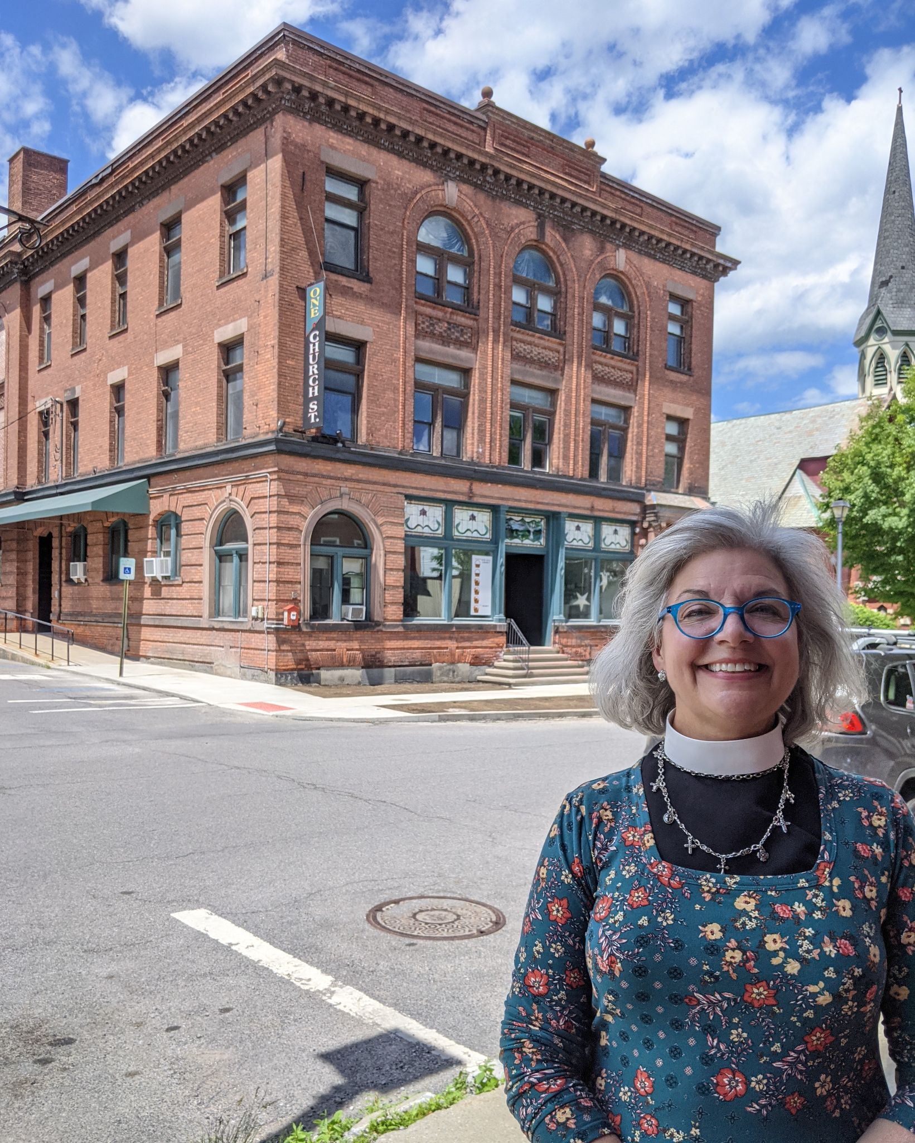
~ We’re In the News ~

“The [NOAH and Food Pantry] programs create important connections between members of the community from all walks of life.”

An extensive article about One Church Street was published this week in the Schenectady Daily Gazette and the Amsterdam Recorder. It covers the overall plans for our One Church Street project and highlights efforts to enhance the NOAH Free Community Meal and the Johnstown Food Pantry. Good news spreads quickly!

Read the article HERE


One Church Street introduces new website!

Want to know what’s new at One Church Street? Want to explain the project to a friend or potential partner? Want to see where the Food Pharmacy is going to go? Check out our new website -- onechurchstreet.org -- to find all those answers and more. Designed by Marj Kline, the new site will keep you up-to-date on the progress of this important project. Please explore it and share it with your friends. Don’t forget to follow us on Facebook as well!

Link to One Church Street Website

Link to Facebook Page

One Church Street PO Box 395 Johnstown, NY 12095
onechurchstreet.org

